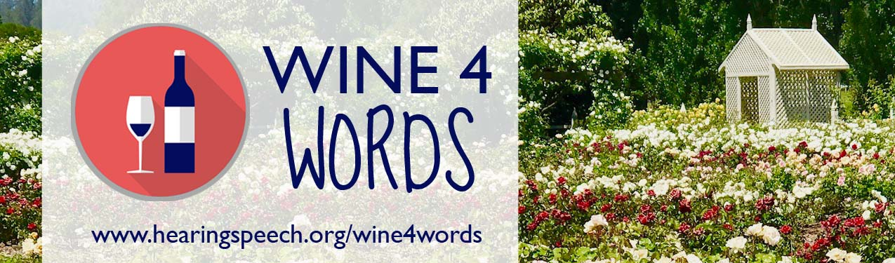

A benefit for the education programs of the Hearing and Speech Center

About Wine 4 Words
The 3rd annual Wine 4 Words fundraiser is on Saturday, October 14th from noon to 4:00 pm at Garden Valley Ranch (498 Pepper Road, Petaluma, CA 94952) and will benefit the Hearing and Speech Center of Northern California’s education programs. This family-friendly event will include wine tasting, food, a silent auction, and live music. Children will enjoy a day of face painting, art projects, and a scavenger hunt!
Why Sponsor?
Your donation will directly benefit the education programs at the Hearing and Speech Center and help us continue to build a more equitable and empowered community!

Sponsorship Objectives
The Hearing and Speech Center would like to ensure you receive recognition that is consistent with your marketing objectives. We will do our best to leverage your sponsorship in a manner that enhances your company’s brand, reputation, and image.

A Lasting Impact
Your participation in Wine 4 Words will change lives! Every day, the Hearing and Speech Center works with children and youth with hearing loss and communication challenges, and we are a leader in our field. No other organization supports children and families with the same breadth of programs - including classroom education, advocacy, counseling, homework groups, social activities, mentorship, and more. Many children come from low-income households and would not otherwise be able to afford services. Your support makes a huge difference!

For more information, please contact Sarah Pikal at spikal@hearingspeech.org or (415) 921-7658.

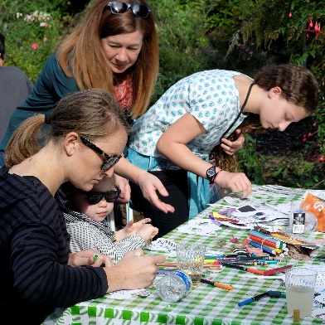

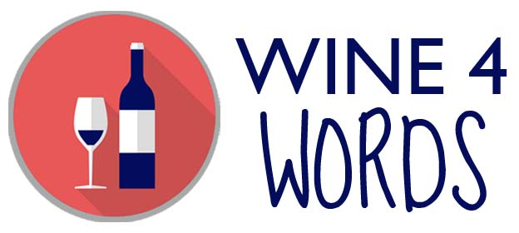

Saturday, October 14, 2017, Noon – 4:00 pm
Garden Valley Ranch in Petaluma
(498 Pepper Road, Petaluma, CA 94952)
www.hearingspeech.org/wine4words

Sponsorship Opportunities

Title Sponsor - $10,000
• Exclusive naming rights to the 2017 event
• Special event signage
• Name and largest logo on event promotions: website, Facebook, e-newsletter and newsletter
• Frequent recognition via social media leading up to the event, including tailored messaging, if desired
• 10 tickets
• Back page in program book (color)
• Opportunity to speak at event
• Name and logo on invitation and program cover
• Quote and statement in our newsletter and media release
• Other deliverables are negotiable to meet you marketing objectives

Leading Sponsor - $5,000
• Opportunity for special event signage (will not interfere with Title Sponsor’s right to most prominent
signage)
• Frequent recognition via social media leading up to the event
• 5 tickets
• Full page color ad in program book
• Logo with listing in program book
• Name and logo on website, Facebook, e-newsletter and newsletter

Supporting Sponsor - $2,500
• 5 tickets
• Full page color ad in program book
• Logo with listing in program book
• Name and logo on website, Facebook, e-newsletter and newsletter

Community Sponsor - $1,000
• 5 tickets
• Half page ad in program book
• Listing in program book
• Name and logo on website, Facebook, e-newsletter and newsletter

Yes, I would like to support the Hearing and Speech Center and sponsor Wine 4 Words!

Name:

Business Name:

Address:

City, State, ZIP:

Phone: Email:

Title Sponsor - $10,000

Leading Sponsor - $5,000

Supporting Sponsor - $2,500

Community Sponsor - $1,000

I can’t attend the event, please accept my donation of $

Logos and print ads must be submitted by October 1. Please email color graphics to Sarah at spikal@hearingspeech.org as a high resolution jpg or as a vector file.

Please send this form along with a check or credit card payment to:

Hearing and Speech Center of Northern California
Attn: Development
1234 Divisadero St.
San Francisco, CA 94115

To pay by credit card, please provide:

Name on card: Card number: Exp: Billing address:

For questions or more information, contact Sarah Pikal at 415-921-7658 or spikal@hearingspeech.org.

The mission of the Hearing and Speech Center of Northern California is to provide life-long professional services to help people with communication challenges in achieving their goals. We are a 501(c)(3) nonprofit.

